Sponsorship Form

Company:

Name & Title, as it appears on collateral material:

Phone:

Fax:

Email:

Authorizing Signature:

Payment

q Check or Money Order enclosed
q Invoice
q American Express

payable in US dollars, to PIA MS
q Visa q Mastercard

Level of Sponsorship
q Captain’s Circle

q Diamond

q Platinum

q Gold

q Silver

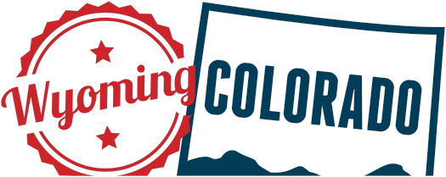
Billing Address:

City: State: Zip:

Account Number: Exp Date: Security Code:

Name on Card:

Signature:

Please fax a copy to (303) 806-8710 to verify commitment.

printing industries of america mountain states

